**SDF LAB WEEK 3**

**Q1.**

**# include<iostream>**

**# include<math.h>**

**using namespace std;**

**class triangle**

**{**

**float a,b,c;**

**public:**

**void get()**

**{**

**cout<<"Enter the dimensions of the triangle :";**

**cout<<endl<<"a : ";**

**cin>>a;**

**cout<<endl<<"b : ";**

**cin>>b;**

**cout<<endl<<"c : ";**

**cin>>c;**

**}**

**void display(float x)**

**{**

**cout<<x<<endl<<endl;**

**}**

**void perimeter()**

**{**

**float perimeter=a+b+c;**

**cout<<"The perimeter is :";**

**display(perimeter);**

**}**

**void area()**

**{**

**float s;**

**s=(a+b+c);**

**s=s/2;**

**float ar;**

**ar=(s*(s-a)*(s-b)*(s-c));**

**cout<<"The area is :";**

**cout<<ar<<endl;**

**display(ar);**

**}**

**};**

**// end of class**

**int main()**

**{**

**triangle t1;**

**t1.get();**

**t1.area();**

**t1.perimeter();**

**}**

**OUTPUT**

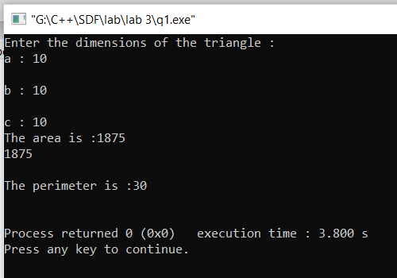

**Q2.**

**# include<iostream>**

**# include<math.h>**

**using namespace std;**

**class triangle**

**{**

**float a,b,c;**

**public:**

**void display(float x)**

**{**

**cout<<x<<endl<<endl;**

**}**

**void perimeter()**

**{**

**float perimeter=a+b+c;**

**cout<<"The perimeter is :";**

**display(perimeter);**

**}**

**void area()**

**{**

**float s= a+b+c/2;**

**float a= sqrt(s*(s-a)*(s-b)*(s-c));**

**cout<<"The area is :";**

**display(a);**

**}**

**triangle(){**

**a=10;**

**b=20;**

**c=30;**

**}**

**};**

**// end of class**

**int main()**

**{**

**triangle t1;**

**t1.area();**

**t1.perimeter();**

**}**

**OUTPUT**

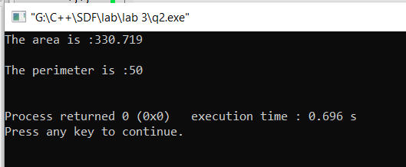

**Q3.**

**# include<iostream>**

**using namespace std;**

**class complex**

**{**

**int r1,r2,i1,i2;**

**public:**

**void getr()**

**{**

**cout<<"Enter the real part of first real no :";**

**cin>>r1;**

**cout<<"Enter the real part of second real no :";**

**cin>>r2;**

**}**

**void geti()**

**{**

**cout<<endl<<endl;**

**cout<<"Enter the imaginary part of first real no :";**

**cin>>i1;**

**cout<<"Enter the imaginary part of second real no :";**

**cin>>i2;**

**}**

**void sum()**

**{**

**int r_net=r1+r2;**

**int i_net=i1+i2;**

**cout<<endl<<"Sum : "<<endl<<r_net<<" + "<<i_net<<"j";**

**}**

**void difference()**

**{**

**int r_net=r1-r2;**

**int i_net=i1-i2;**

**cout<<endl<<"difference : "<<endl<<r_net<<" + "<<i_net<<"j";**

**}**

**void product()**

**{**

**/*a+ib**

**c+id**

**(ac - bd) + i (ad+bc)*/**

**int r_net=r1*r2 - i1*i2;**

**int i_net=r1*i2 + r2*i1;**

**cout<<endl<<"Product"<<endl<<r_net<<" + "<<i_net<<"j";**

**}**

**};**

**// end of class**

**int main()**

**{**

**complex c1;**

**//function calling**

**c1.getr();**

**c1.geti();**

**c1.sum();**

**c1.difference();**

**c1.product();**

**}**

**OUTPUT**

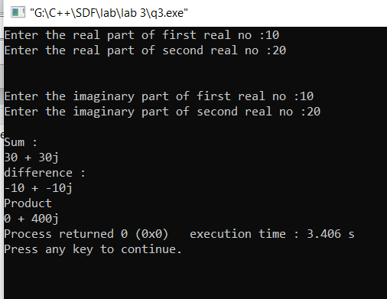

**Q4.**

**# include<string.h>**

**#include<iostream>**

**using namespace std;**

**class first**

**{**

**char studentname[20];**

**public:**

**void printname()**

**{**

**cout<<studentname;**

**}**

**first()**

**{**

**strcpy(studentname,"Narendra Modi G");**

**printname();**

**}**

**};**

**int main()**

**{**

**first s;**

**}**

**OUTPUT**

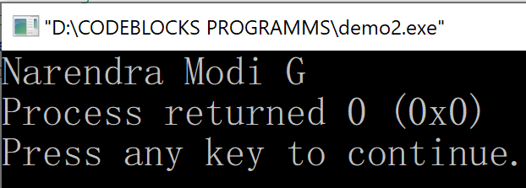

**Q5.**

**# include<iostream>**

**using namespace std;**

**class second**

**{**

**int person_id;**

**public:**

**void display (int x)**

**{**

**cout<<"Entered data is :"<<x<<endl<<endl;**

**}**

**second ()**

**{**

**person_id=1002;**

**display(person_id);**

**}**

**second (int x)**

**{**

**person_id=x;**

**display(person_id);**

**}**

**};**

**// end of class**

**int main()**

**{**

**second obj1;**

**second obj2(200);**

**}**

**OUTPUT**

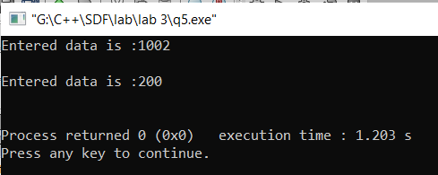

**Q6.**

**# include<iostream>**

**using namespace std;**

**class area**

**{**

**float l,b,a;**

**public:**

**void getdim()**

**{**

**cout<<"Enter the length : ";**

**cin>>l;**

**cout<<"Enter the breadth : ";**

**cin>>b;**

**}**

**float getarea()**

**{**

**return l*b;**

**}**

**};**

**// end of class**

**int main()**

**{**

**area a;**

**a.getdim();**

**float ar=a.getarea();**

**cout<<endl<<"The area is :"<<ar;**

**}**

**OUTPUT**

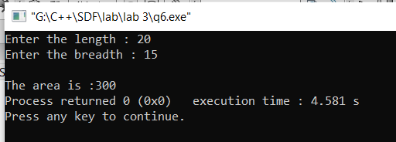

**Q7.**

**# include<iostream>**

**using namespace std;**

**class student**

**{**

**int m1,m2;**

**float avg;**

**public:**

**student()**

**{**

**m1=55;**

**m2=65;**

**}**

**void calculateAverage(student s)**

**{**

**float total=s.m1+s.m2;**

**avg=total/3;**

**cout<<"Average is : "<<avg;**

**}**

**};**

**//end of class**

**int main()**

**{**

**student s1;**

**s1.calculateAverage(s1);**

**}**

**OUTPUT**

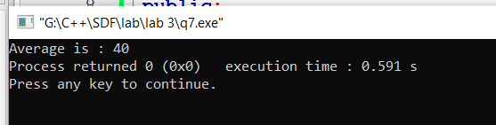

**Q8.**

**#include<iostream>**

**# include<string.h>**

**using namespace std;**

**class details**

**{**

**char name[50],branch[15];**

**int en_no;**

**float cgpa;**

**public:**

**void get()**

**{**

**cout<<"Enter the details :";**

**cout<<endl<<"Name :";**

**cin>>name;**

**cout<<"Branch";**

**cin>>branch;**

**cout<<"Enrol. No. :";**

**cin>>en_no;**

**cout<<"CGPA : ";**

**cin>>cgpa;**

**}**

**void display()**

**{**

**cout<<endl<<endl<<"Details are : "<<endl;**

**cout<<"Name : "<<name;**

**cout<<endl<<"Branch : "<<branch;**

**cout<<endl<<"Enrol. No. : "<<en_no;**

**cout<<endl<<"CGPA : "<<cgpa;**

**}**

**details(char n[],char br[],int en, float c)**

**{**

**strcpy(name,n);**

**strcpy(branch,br);**

**en_no=en;**

**cgpa=c;**

**display();**

**}**

**details(char n[],int en, float c)**

**{**

**strcpy(name,n);**

**strcpy(branch,"C.S.E");**

**en_no=en;**

**cgpa=c;**

**display();**

**}**

**details()**

**{**

**strcpy(name,"Unknown");**

**strcpy(branch,"C.S.E");**

**en_no=1;**

**cgpa=6;**

**display();**

**}**

**};**

**//end of class**

**int main()**

**{**

**details d1("Any_one","CSE",1,9.8);**

**details d2("No_one",1,9.8);**

**details d3;**

**cout<<endl<<endl;**

**details d4;**

**d4.get();**

**d4.display();**

**}**

**OUTPUT**

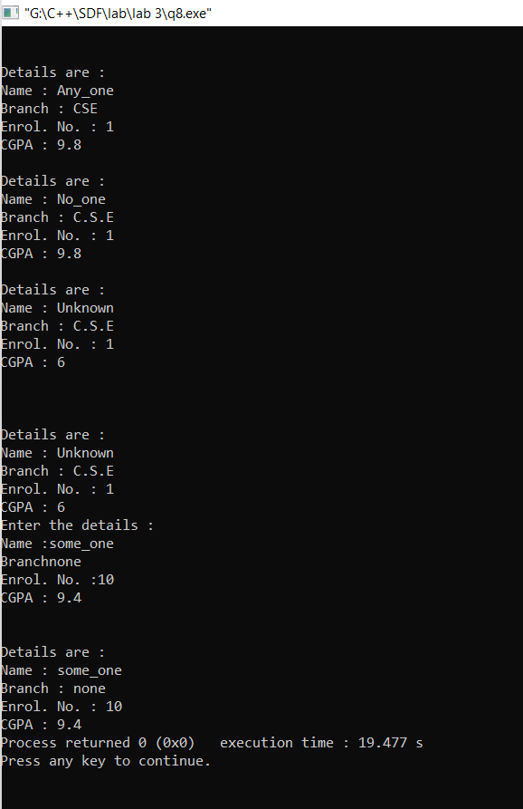

**Q9.**

**#include<iostream>**

**using namespace std;**

**class bill**

**{**

**int no;**

**float units,c1,c2,c3;**

**float total;**

**public:**

**void get()**

**{**

**cout<<"Enter the consumer No ; ";**

**cin>>no;**

**cout<<"Enter the no of units consumed :";**

**cin>>units;**

**calcBill();**

**put();**

**}**

**void calcBill()**

**{**

**if (units<=100)**

**{**

**total=c1*units;**

**}**

**if (units>100 && units<=200)**

**{**

**total=(100*c1)+(units-100)*c2;**

**}**

**if (units>200)**

**{**

**total=(100*c1)+(units-100)*c2+(units-200)*c3;**

**}**

**}**

**void put()**

**{**

**cout<<"Details are :"<<endl;**

**cout<<endl<<"Consumer No : "<<no;**

**cout<<endl<<"Units Consumed : "<<units;**

**cout<<endl<<"total Bill : "<<total;**

**}**

**bill()**

**{**

**c1=5;**

**c2=7;**

**c3=11;**

**}**

**};**

**// end of class**

**int main()**

**{**

**bill b1;**

**b1.get();**

**}**

**OUTPUT**

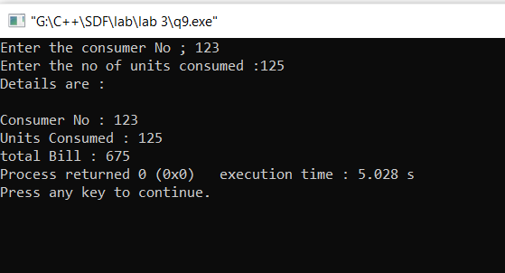

**Q10.**

**1.a = 10, l1.b = 15**

**p2.a = 10, l2.b = 15**